Making an LED Blink

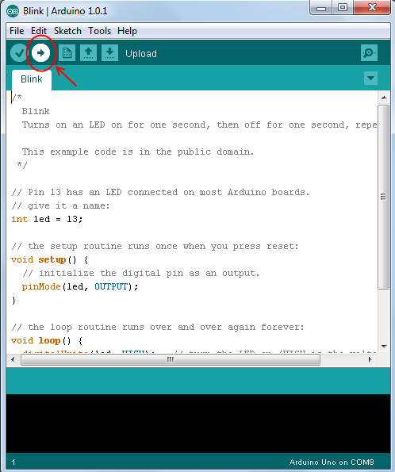
- Create a circuit as shown on last page
- Load up Arduino IDE program on your computer
- In the menu at the top of the arduino program go to File → Examples → 01.Basics → Blink
It should load up some code that looks like the text on the page below
- Make sure the board type and port is set-up correctly in the program, ask a helper if you are unsure about how to do this
- Plug in your arduino board to your computer
- Upload your code to arduino using the upload button (See picture to right)
- Your LED(mini light bulb) should now blink
- Look at the code, play with it by changing lines and then uploading to the board to see what each line does and then figure out how to make the LED blink faster.

Extensions

- Create a train crossing sign using two LEDs and program the arduino so each LED takes turns to turn on.
- Create a traffic light using 3 different colour LEDs and program the arduino to turn them on in the correct order.

Program Code (File → Examples → 01.Basics → Blink)
Below is the blocks we used in scratch. Notice how our new program code is very similar to the blocks we used before. The void loop(){ } acts as a forever loop block, with the code between {} being repeated forever, like the blocks between the forever block.

int led = 13;
// the setup routine runs once when you press reset:

void setup() {
// tell board that pin 13 is an output.
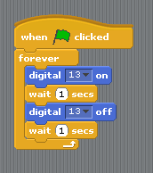
pinMode(led, OUTPUT);

}

// the loop routine runs over and over again forever:
void loop() {
digitalWrite(led, HIGH); // turn the LED on
delay(1000); // wait for a second
digitalWrite(led, LOW); // turn the LED off
delay(1000); // wait for a second
}

Circuit Diagram
LED only works if plugged into the circuit the correct way round. The longer leg should be on the right.
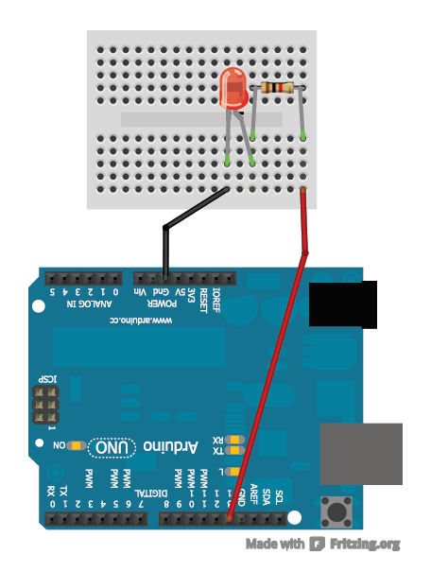

1K ohm Resistor

Connect red wire to Pin 13, then in the program code we tell the board that we have plugged the circuit into pin 13 with line: int led = 13;

